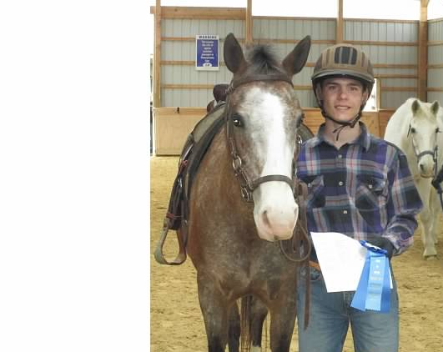
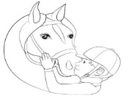
Reins of Rhythm Horse Show
SPONSOR FORM
“Reins of Rhythm started with a single horse, a handful of riders and a young girl’s dream of a place where horses bring youth from all backgrounds - special needs, able bodied, rich, poor, happy, sad - together to build friendships and skills that will last a lifetime. This simple beginning has led to a program that now has eight horses, multiple volunteers, sixty youth in our regular weekly lesson schedule and over two hundred youth in our community outreach events and activities. With the support and prayers of everyone who loves Reins of Rhythm, I’m confident that together we can continue providing an enriching, wholesome, loving and inclusive environment through the use of horses!”
Patience Groomes ~ Program Founder & Director

Please consider helping me with my sponsorship goal to raise money for REINS OF RHYTHM - SPRING HORSE SHOW
SATURDAY May 20th, 2017
Reins of Rhythm’s mission is to provide an inclusive environment where children, able-bodied and special need, are brought together through a common love of horses and are educated in all areas of horsemanship, as appropriate, to help develop a complete equestrian education in safe and fun environment. The goal of Reins of Rhythm has always been that limited finances will never prevent a child from experiencing the great benefits that can come from working with horses. Sponsorships from individuals, businesses, and friends of Reins of Rhythm are what make this happen. Sponsorship Deadline: Saturday May 15th, 2017

Please fill out the information below to become a sponsor.

I/we would like to provide a sponsorship at the following level:
$ 25.00
$ 50.00 – Recognition on Website
$ 100.00 – Recognition on Website and Facebook Page
$ 200.00 - $500.00 –All of the above recognition and mention in our Spring Horse Show Program
$ 500.00 – $1500.00 – All of above recognition and a “Friend of Reins of Rhythm” donor certificate
$ other amount *
- Check here if you wish to remain anonymous.
- Check here if you would like to receive a receipt for tax purposes.
*Highest sponsor for the Spring Horse Show will receive a plaque.

PARTICIPANT NAME(s): ___________________
Business Name:________________________________________________________________________________
Your Name:____________________________________ Address: _______________________________________
City: ________________________________________ State: Zip:
Email: ____________________________________________Phone: _____________________________________

Please make checks payable to: Reins of Rhythm | 4035 McClays Mill Rd, Shippensburg, PA 17257
Reins of Rhythm, is a non-profit organization, as declared tax-exempt by the federal government by section 501 C 3 of the IRS tax code and the Commonwealth of Pennsylvania. A copy of our official registration may be obtained by contacting the PA Dept. of State at 800-732-0999. All donations made to Reins of Rhythm are tax deductible.

LIKE us on FACEBOOK! www.reinsofrhythm.org E-mail: info@reinsofrhythm.org

