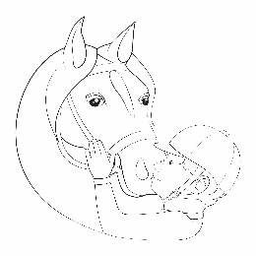
Reins of Rhythm Riding & Horsemanship
2017 Dressage Musical Free Style Spring Show
The 2017 Spring Horse Show is open to Reins of Rhythm participants in the regular lesson program and for group lesson program riders that have been in two consecutive group classes and are attending a current group class at the time of the show. The show is not open to community activity participants. Riders will pick a piece of music that they feel matches themselves and their horse and will work to choreograph a dressage piece at their riding level. Parents are encouraged to help them with a theme or costume to go with the music if desired. Riding buddies are welcome and encouraged to pair up and perform together as a duet (Pas de Deux).
As always is our policy at Reins of Rhythm, we do not want any child not able to participate in an activity due to lack of funding. If you are in a situation where seeking sponsorships is not possible and your rider wants to participate, please contact Patience or Beth as soon as possible to work out alternative arrangements.
Date: Saturday May 20th, 2017
Time: 11AM-2PM
There will be a silent auction and Food Booth at the show.
Fundraiser Incentives for Participants:
Caring for horses is a very expensive endeavor. Each of our wonderful horses costs Reins of Rhythm an average of $2,500 per year. This cost includes grain, hay, bedding, supplements, farrier (hoof care) and veterinary costs. Other costs include fly spray, deworming, first aid supplies, as well as equipment repairs and replacement. Lesson fees only cover a small fraction of these costs. Choose a horse to fundraise for as you seek sponsorships.
Up to $50 raised = Opportunity to participate in the show
Up to $200 raised = Photo of your horse
Up to $600 raised = Enlarged Photo of your horse
Up to $1000 raised = Certificate of Sponsorship with enlarged photo of your horse
Up to $2500 raised = Certificate of Sponsorship with enlarged photo of your horse and a duplicate Certificate will be displayed in the arena wait area. You will also receive recognition in the Horse Show Program, on the Reins of Rhythm website and Facebook unless you wish to remain anonymous.
DEADLINE TO TURN IN SPONSORSHIP MONEY IS THURSDAY, MAY 18th

