Happy Birthday
From Reins of Rhythm!
What’s the best way
for your horse-crazy girl or boy to spend their birthday?
With a horse of course!

Reins of Rhythm Riding & Horsemanship offers birthday party opportunities that provide your child with an unforgettable experience and provide us with a little income to help keep our program up and running.
Option #1:
- $75.00 facility fee
- Birthday girl or boy is free!
- $15.00 per additional child
  - With this price package you get an hour of pony rides and interactive games/activities with the horses. You also get use of our indoor arena for an additional hour for presents, cake, etc.
Option #2:
- $125 facility fee
- Birthday girl or boy is free!
- $15.00 per additional child
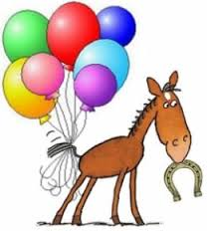
  - With this price package you get an hour of pony rides and interactive games/activities with the horses. You also get use of our Outreach Center for an additional hour for presents, cake, etc. Our Outreach Center has indoor plumbing (bathrooms, running water) and is heated/air conditioned. We also take care of all clean-up afterwards!
Note: For both package options, we require that you have a minimum of 6 children attend the party (including the birthday child). This will ensure that our volunteers’ and horses’ time are being used efficiently. Additionally, while we don’t have a maximum number set at this time, we ask that you consider keeping child numbers under 15 to ensure each child has adequate time with the horses. If you anticipate having more than that we ask that you let us know as soon as possible when scheduling your party.
Please email us at info@reinsofrhythm.org to schedule your party today!

